**LAB 7**

**DANYAL ZAHID**

**24K-0519**

**Q1:**

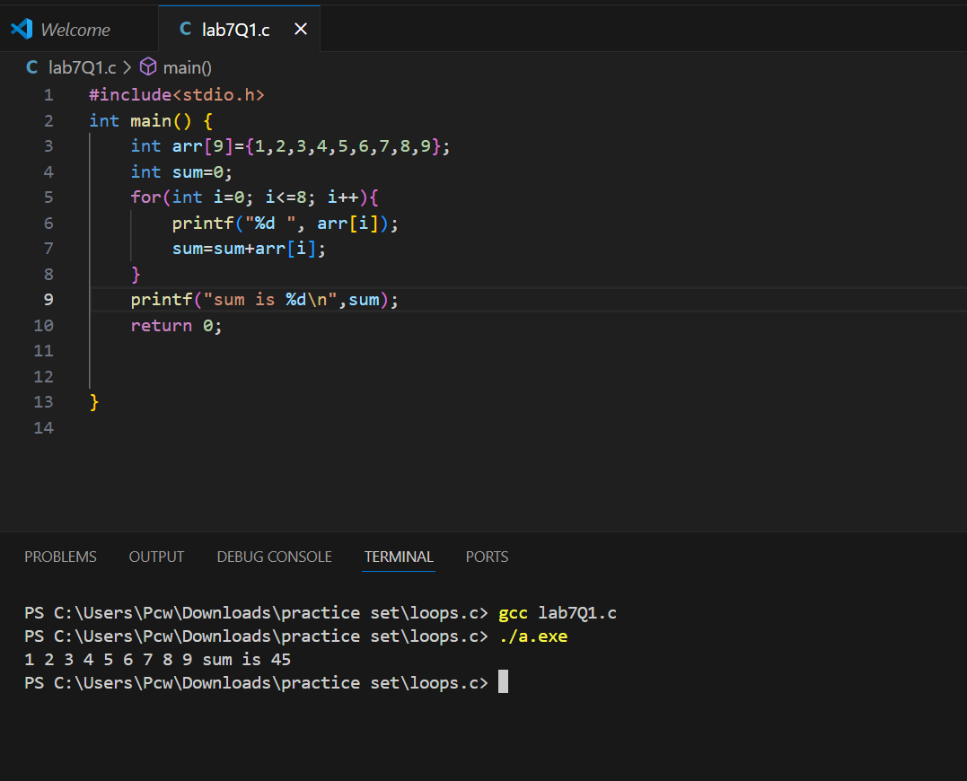

**Q2:**

**Q3:**

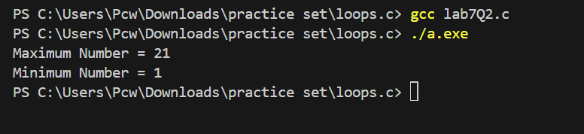

**Q4:**

